**Description to Pizza Restaurant HTML**

The main page is the starter site. The link to this page is: http://kozospizza.eotvos19kispest.nhely.hu/

On top of the pages the user can find a header, with which he can browser between the pages. The home page is the greeting site. It is not possible to click again for name of that page which has opened.

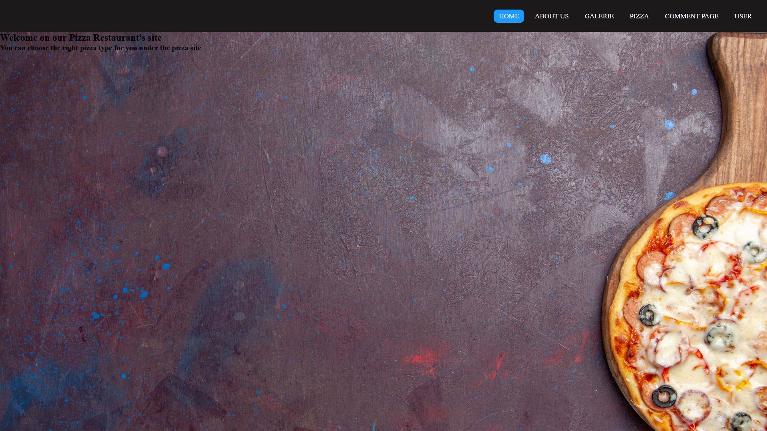

On the “about us” page the user can find some informations about the restaurant as address, phone, email to contact and a little help with maps google to the right location.

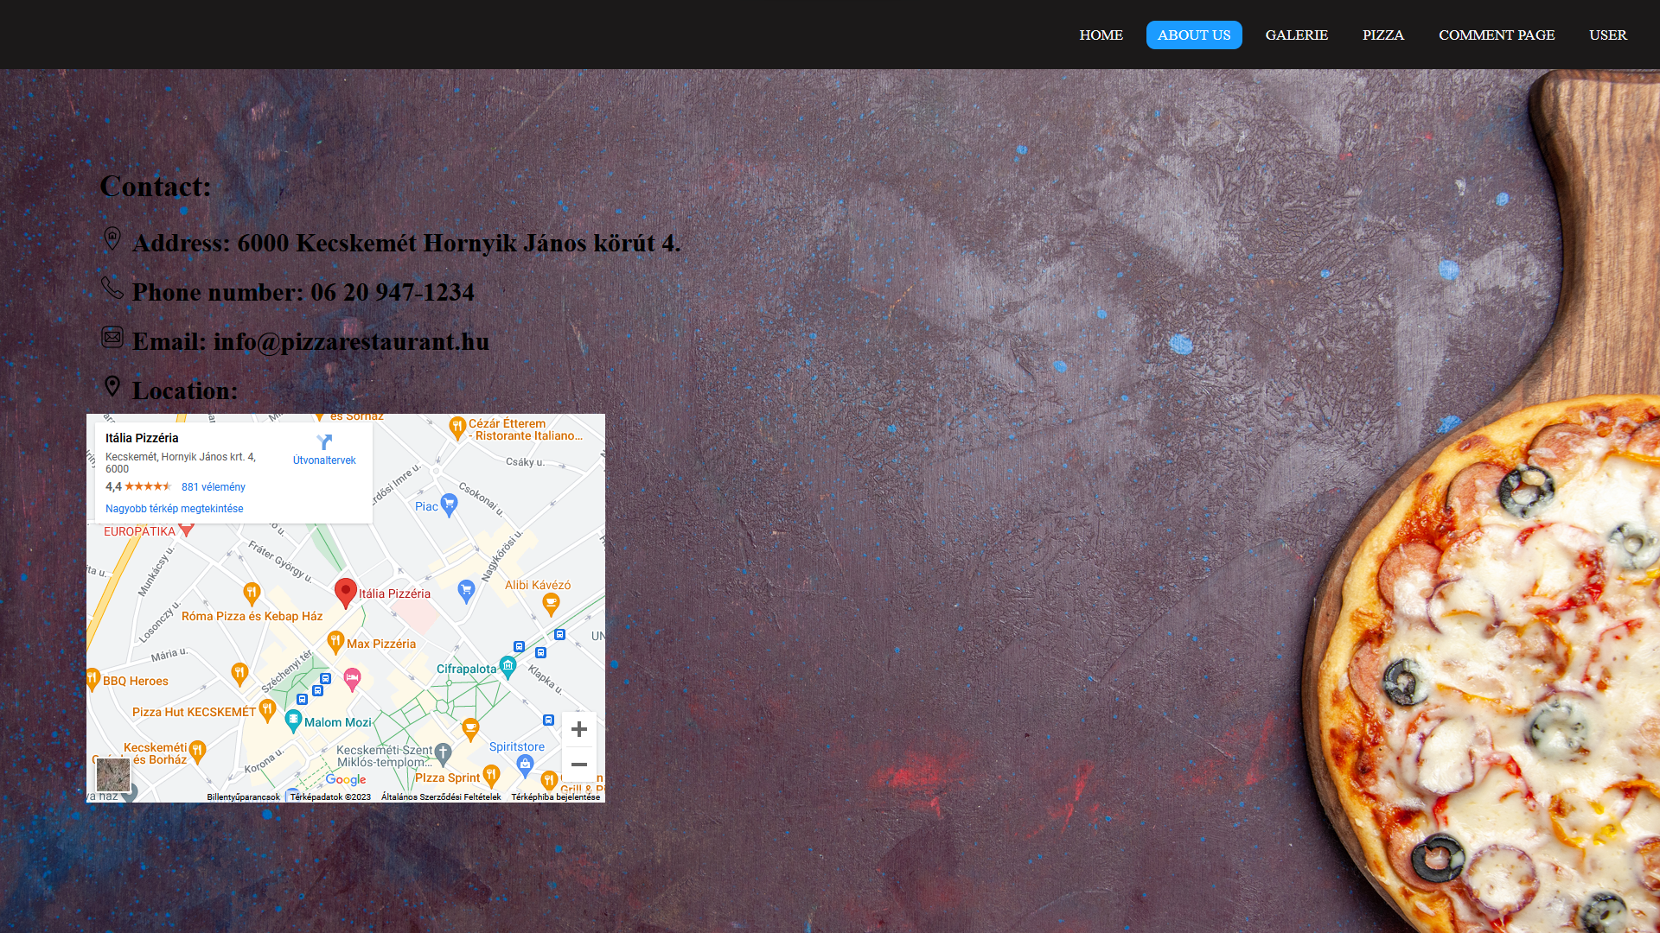

On the “galerie” site are a two links, one of them is video from Youtube, if the user click on it then the Youtube will open. The other is link to the pictures of some pizzas. And there is one video about how is made the pizzas.

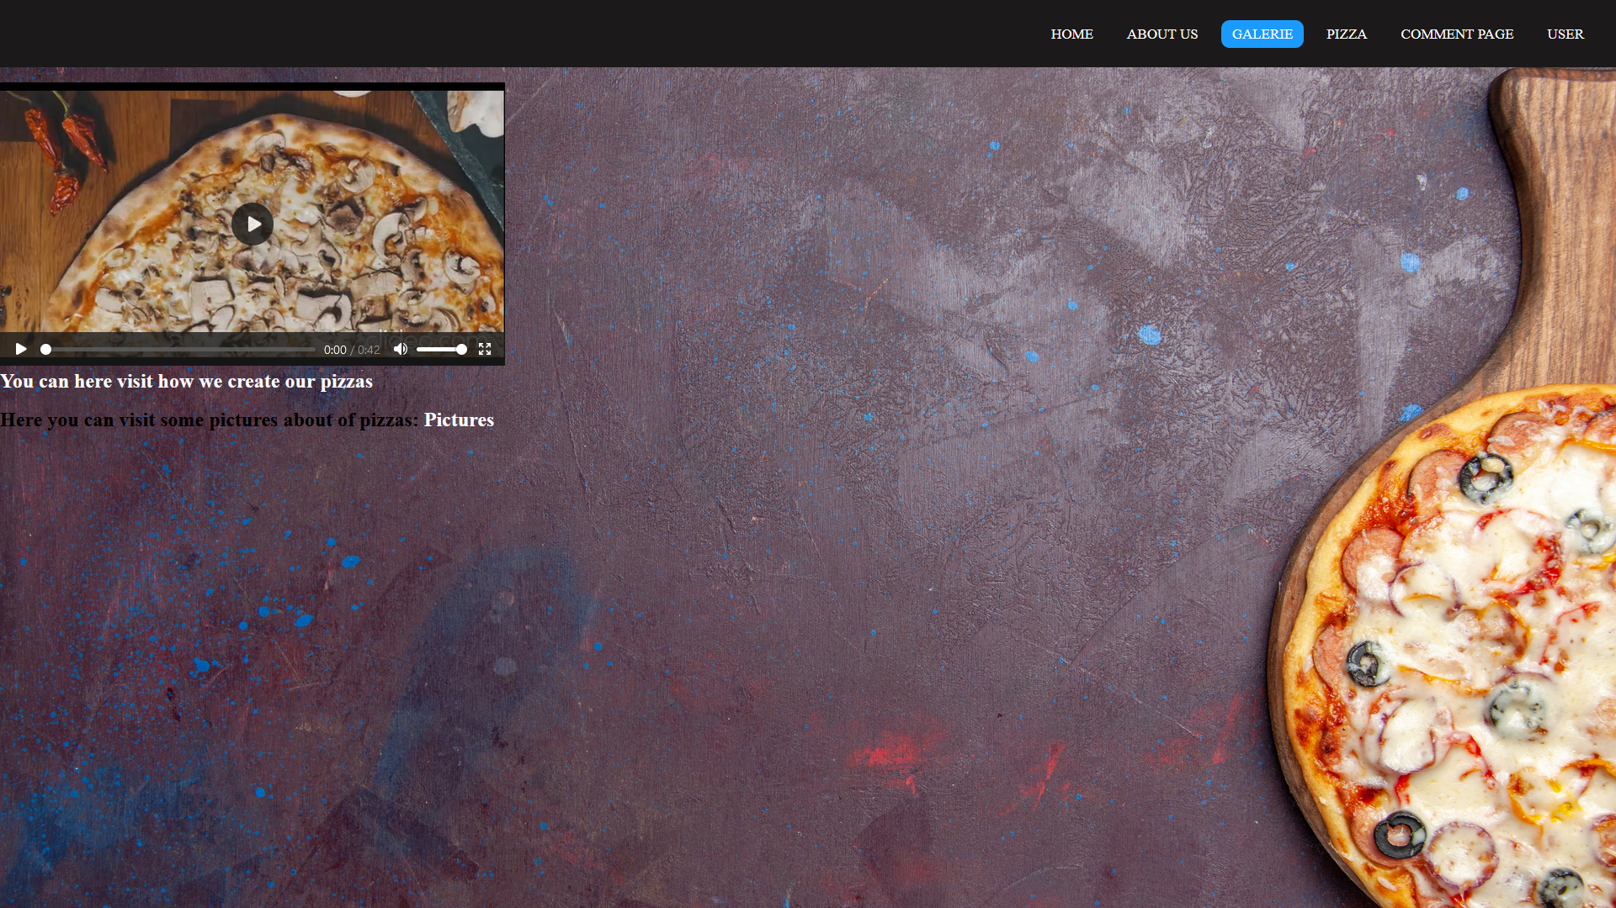

The user need to click on “picture” link to can see the pictures about the pizzas.

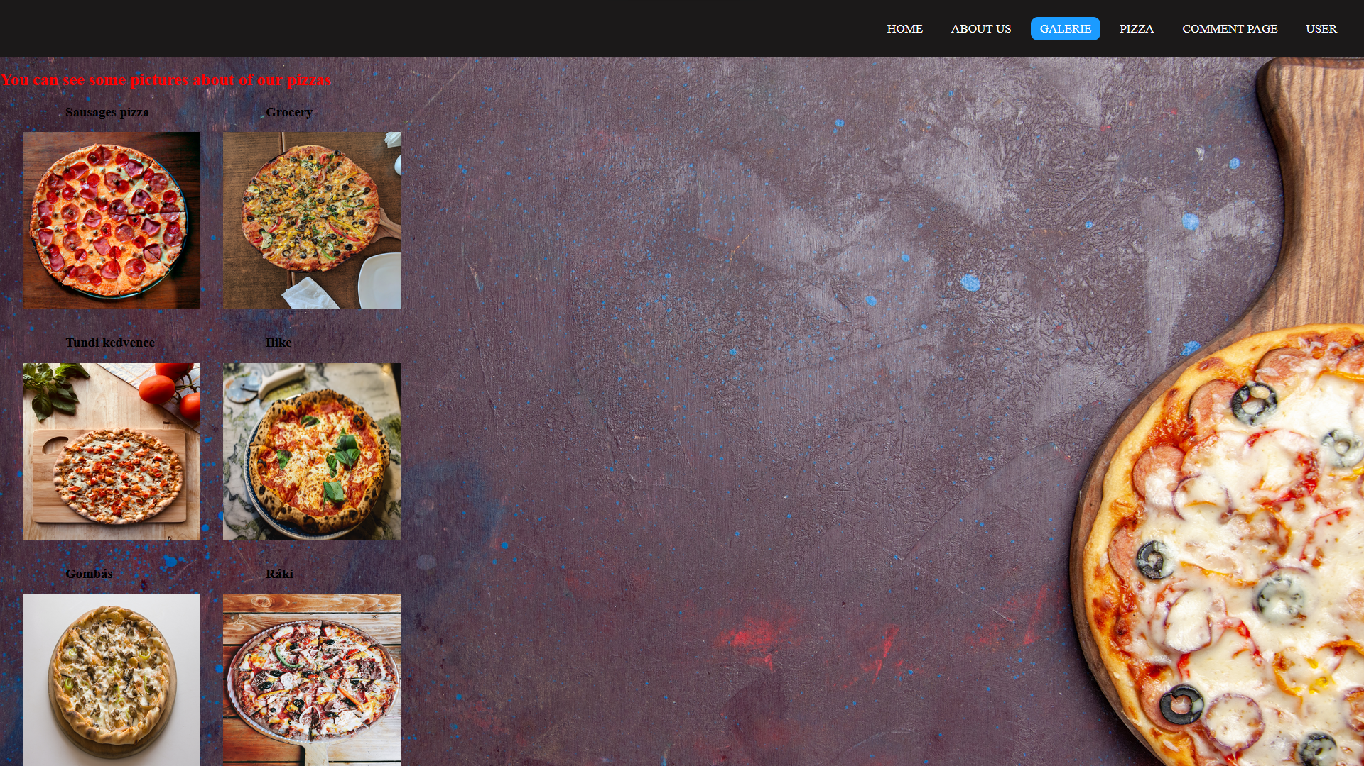

On the pizza site the use can order pizza. He can order at the same time just one type of pizzas. The amount can not be 0 (no choosable), and the maximum is 10. When the page be opened it shows all of type the available pizzas. With the order button the user can order the choosed pizza.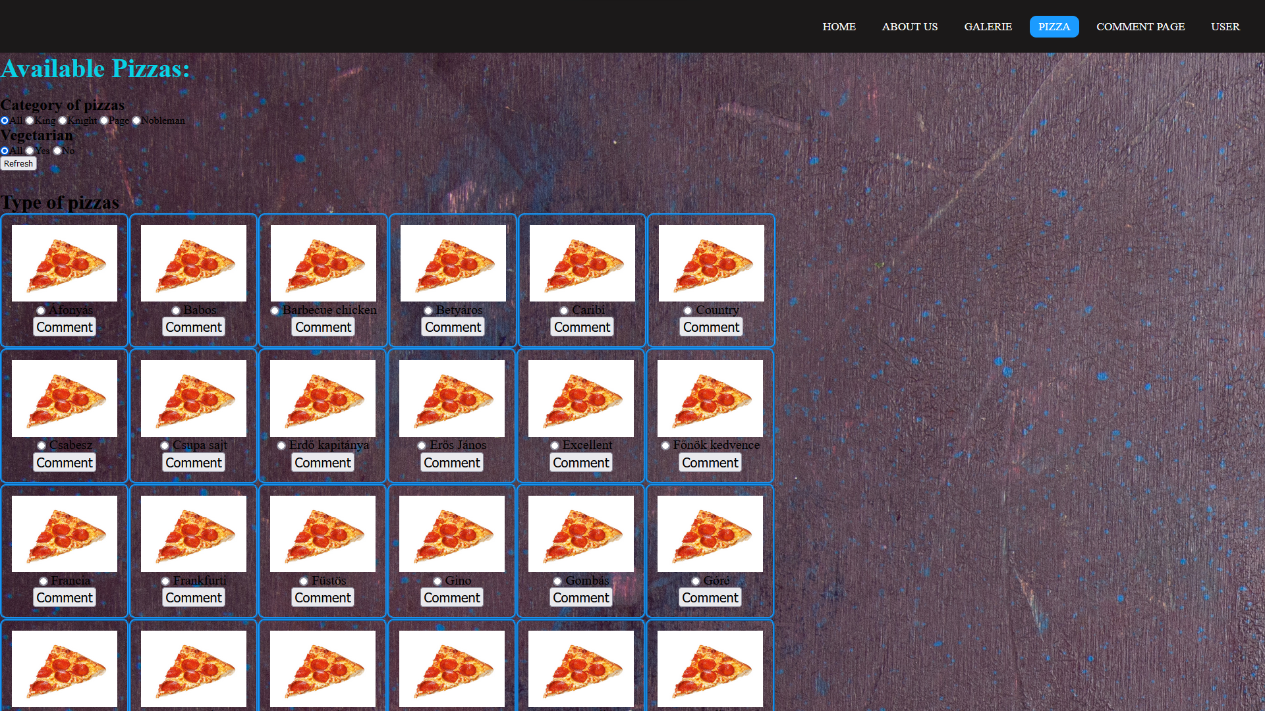 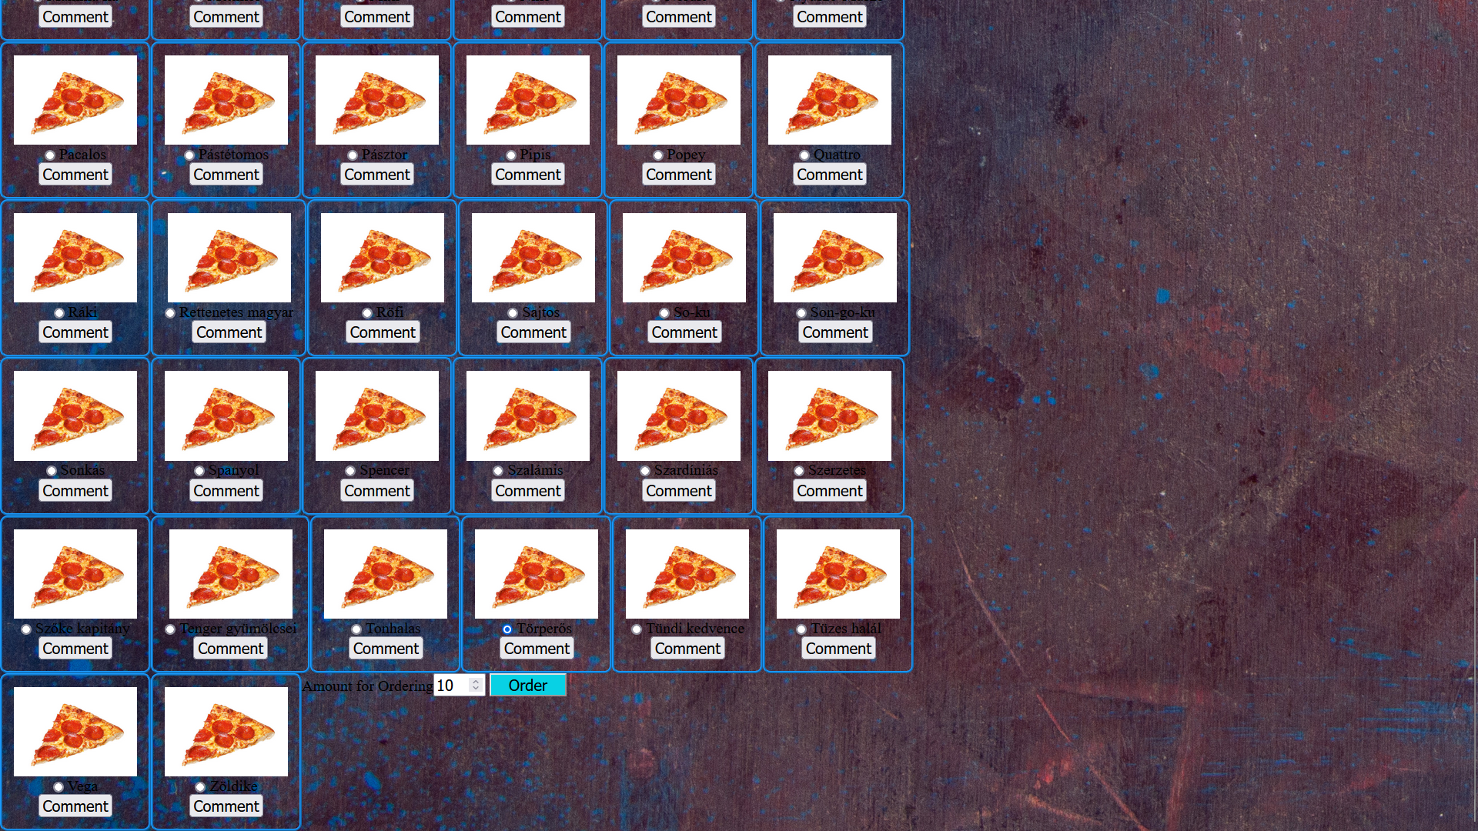

After the ordering the site gives a feedback about the succesfully ordering.

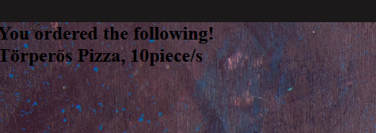

To the easier choosing there is a filter on the top of page. The site is under development so the filter at the moment works just with the base databases. But at the moment the filter can works in every possibilities.

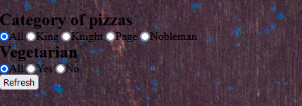

On the comment button is clicked there will open other site where it is possible to write a comment to the pizza.

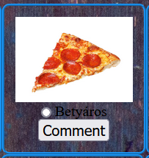

The user can write own experience about the pizza, but the comment can be just 250 characters length. With the send button the comment will be saved in the datebase, and the user can visit it later on the “comment” page.

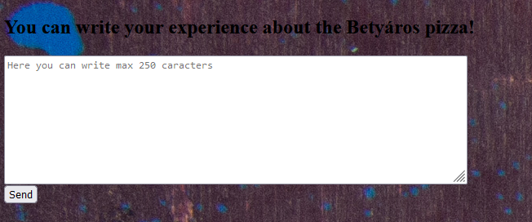

On the comment page the user can visit the comments. With the “edit” button can the user edit and with the “Delete” button can delete the own comment.

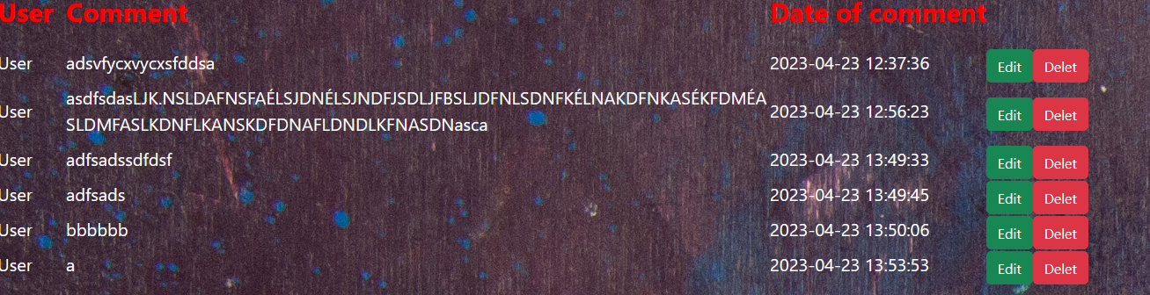

If the user click on “edit” button then he can see the comment in text box in which he can modify the sentence, and with the “Submit” button can save it.

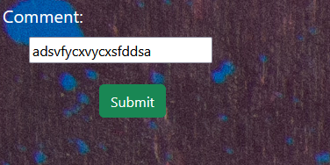

On the “User” page it is possible log in. Or creating a new user on the user registration page.

The user can log in with email and password datas.

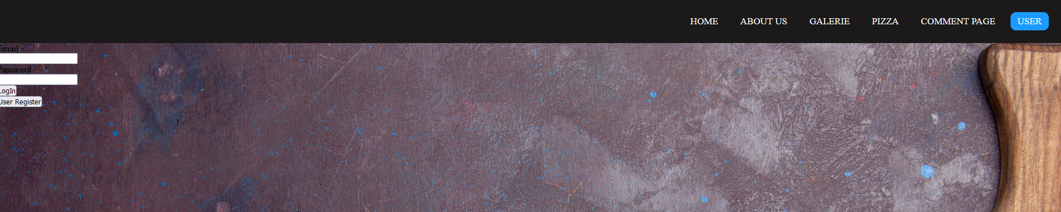

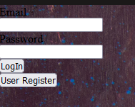

At user registration the user need give the following datas:

* name
* email
* password
* confirm password

With the “registration” button can be finish the registration.

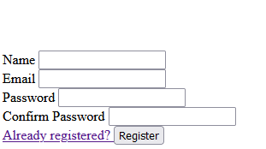

If the user loged in and he isn’t on admin level, then he can modify just the comments.

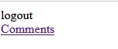

If the user is on admin level, then he can modify everything.

* Users
* Categories
* Pizzas
* Comments
* Orders

The admin the orders just can be visit, the changing is not possible. So the restaurant can not be deny orders, and it is not allowed by the laws.

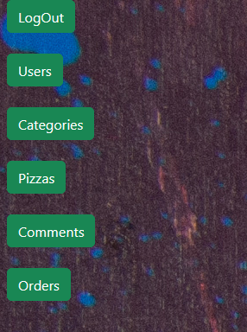

On the Users page, the admin can editing and deleting the exist user names.

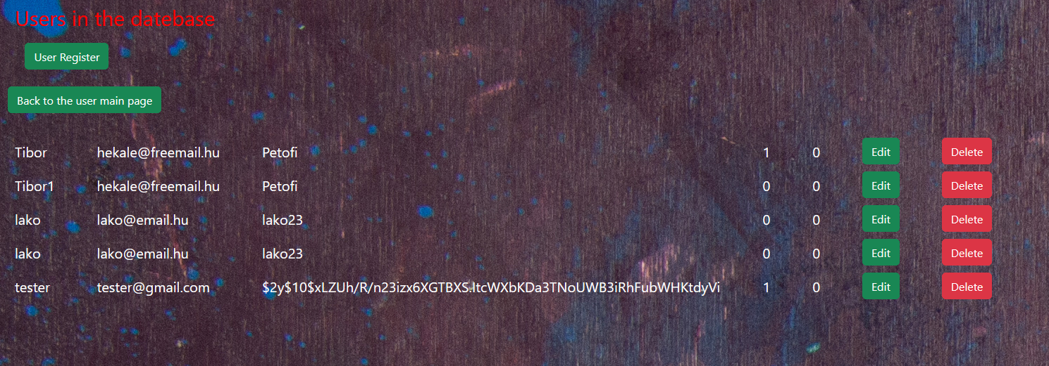

On the Categories page, the admin can modify, edit or delete the categories, or create a new one.

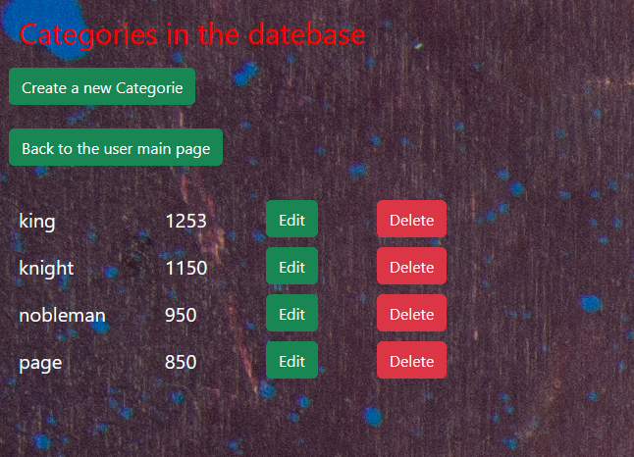

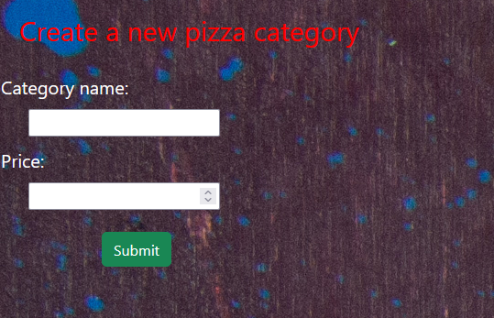

On the pizza page, the admin can modify, delete the exist pizzas, or creating a new one.

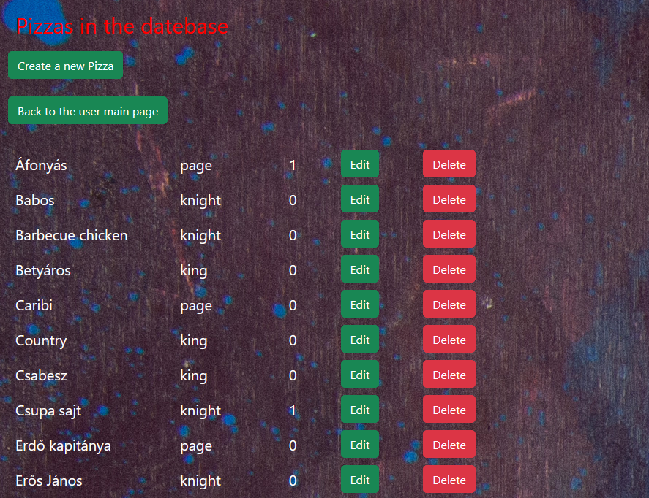

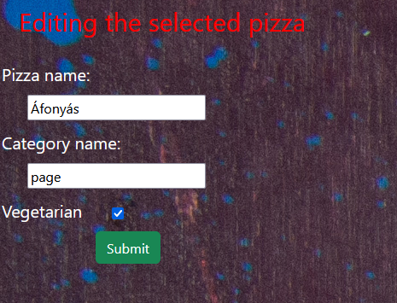

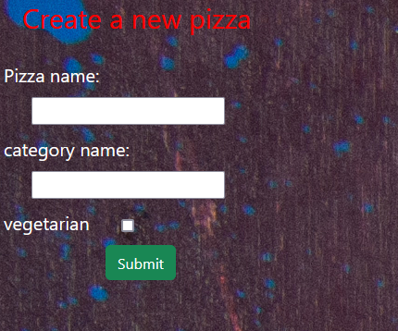

On the comments page the admin can modify and delete the all comments, or creating a new one, but this function is under development.

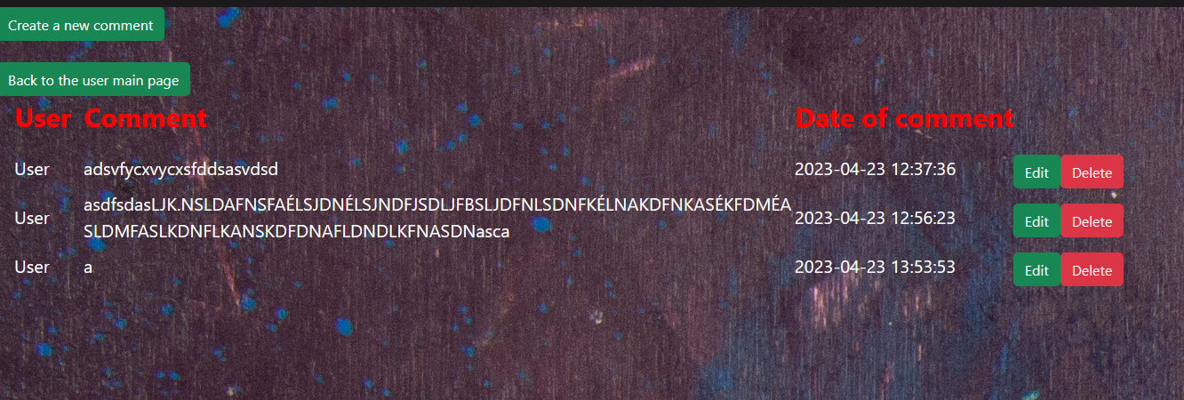

New comment creating page:

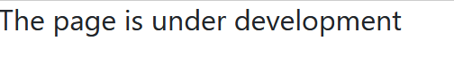

On the orders page the admin can see that the users has ordered.

